Castillo-Palacio Real de OLITE
The Castle-Palace of Kings of Navarra is one of the most important castles of its kind. Jewel of the European gothic castles, Olite castle-palace was the former residence of the Kings of Navarra until the union of the kingdom with Castile in the 13th century. It was declared a National Monument in 1925. During the 13th-14th centuries underwent alterations, but the most important development came during the times of King Carlos III “the Noble”.
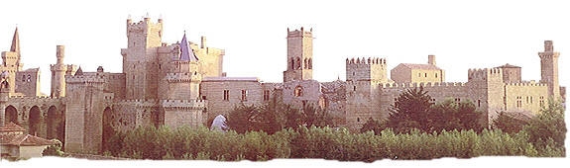
The plan for the tour is as follows

Guided visit of the Royal Palace of Olite (45 min approx) | 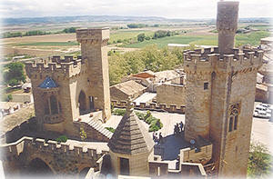
Guided visit of the Santa María church (30 min approx) | 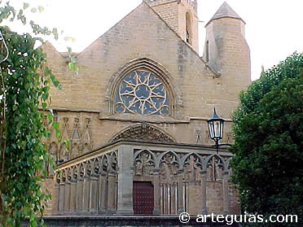
Wine tasting at the Morera Yard of the Palace | 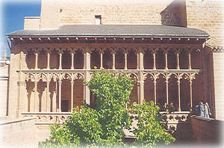
Come back to Pamplona for the Gala dinner

All the information during the tour will be explained in English.

THE ROYAL PALACE OF OLITE

The Palacio Real (Royal Palace) of Olite, the seat of the Court of Navarre until its union with Castile (1512), was one of the most luxurious mediaeval castles in Europe. A 12th-century German traveller wrote his impressions in his diary, now conserved in the British Museum in London: "Surely there is no king with a more beautiful castle or palace and with so many gilded rooms".
Looking at its majestic profile and the elegance of its whimsical towers, it is not hard to imagine oneself back in the mediaeval era and to feel the life of the Court in a palace that was richly decorated and had exotic gardens and even a zoo! Jousts and tournaments were held here, as were pelota games and even bullfights. Olite evokes that past today, in which it became the seat of the Court during the reign of King Carlos III 'el Noble', during its annual Mediaeval Fair.
The Royal Palace of Olite is proof of the splendour of the Court that Olite hosted during the Middle Ages. This historic town is located in the Central Zone of Navarre, 42 kilometres south of Pamplona. Declared a National Monument in 1925, it covers one-third of the old part of the town and is considered one of the most interesting Gothic complexes in Europe.
It was built over the remains of an ancient Roman fortress and underwent many transformations during the 13th-14th centuries. This part is known as the Palacio Viejo (Old Palace) and now houses the "Príncipe de Viana" Parador Nacional. Of the original building only the outer walls and the towers are conserved. Its façade is characterised by its large Gothic windows, the Renaissance main entrance and the watchtower.
Its greatest splendour, however, was in the early 15th century thanks to King Carlos III 'el Noble', who brought a number of Iberian and European master builders to work on the castle-palace. The Palacio Nuevo was built in the French Gothic style of civil architecture. The King, who was born in Nantes, came from a great dynasty of French nobles, whose influence spurred on his imagination and good taste in the Palace at Olite, which became his favourite residence.
The palace was partially destroyed when it was set on fire in 1813 by General Espoz and Mina to stop the French troops holing up in the castle during their retreat. Its current form is the result of a meticulous restoration carried out in 1937, which set out to give the palace its original appearance back. It is characterised by large stone walls along a perimeter of recesses and projections, and circular towers with slate roofs on each corner.
A large courtyard provides access to the interior, which can be visited with a guide. Next to this courtyard, an old grapefruit tree garden, are two others called the “Pajarera” (aviary) and the “Morera” (white mulberry tree). The centuries-old white mulberry tree in the latter has been declared a National Monument.
Behind these is the heart of the Palacio Nuevo, on whose 'noble' floor the King's chambers are conserved, with wide bell-shaped windows, and also those of the Queen. From the first chamber you access the Galería del Rey (King's Gallery), while the Queen's chamber communicates with a small patio called the “Naranjo” (orange tree) or “Jardín de la Reina” (Queen's garden).
Over this central part of the Palace that houses the chambers rises the silhouette of the castle's crenelated towers. The tallest and most spectacular is the “Torre del Homenaje” (Tribute Tower), while the most whimsical is the one called “Tres Coronas” (Three Crowns). The monarchs used to follow the tournaments from the “Cuatro Vientos” (Four Winds) tower. There are no tournaments to be seen now, but the view is still beautiful.
In the shadiest area of the palace you will find the pozo del hielo (ice well), whose cover recalls a great egg shell. Snow was kept in it to conserve food, which is why it received the nickname of “la nevera” (the fridge).
During your visit try and visualise the luxury that existed here. There were exotic gardens, some suspended 20 metres up, and a small zoo with lions in the (now disappeared) Jardines o Huertos del Rey (King's Gardens) to the east of the present Palace. Its walls were richly decorated with tiles, plasterwork and carved wood ceilings. After the fire, only the decoration of the room known as the 'Cámara de los Yesos' (Plaster Chamber) was preserved.
It was the scene of games such as pelota and rackets and, on special occasions, jousts and tournaments were held, such as the one organised during the wedding of the Princess from Burgundy Agnes de Clèves to the Prince of Viana, son of Carlos III (this title is held today by the Princes of Asturias). Another very popular event was the bullfight.

And as well as the Palace...
From the square that acts as a kind of anteroom to the castle you go up a spiral staircase to the mediaeval galleries where there is an exhibition on the life of the Court of King Carlos III 'el Noble'.
You can round off your visit to the palace by entering the Gothic church of Santa María and the Romanesque San Pedro, which has a cloister and a graceful Gothic tower with a spire on top, rivalling the towers that mark out the profile of the Palace. You can also visit the most complete and best preserved Roman walls in Navarre if you walk out to the city walls. Stroll through the streets at leisure, but to finish your stay have a good meal of the area's specialities, accompanied by the reputed wines of Olite, which are produced under the 'Navarra' Designation of Origin. Do not miss the Wine Museum of Navarre, which is located in Olite.
If you want to step back in time to the Middle Ages, there is nothing better than the Mediaeval Fair held in Olite over three days in August. On summer evenings, part of the programme of the Classical Theatre Festival of Olite takes place outdoors just behind the Palace.
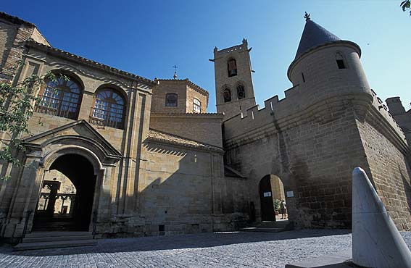 | 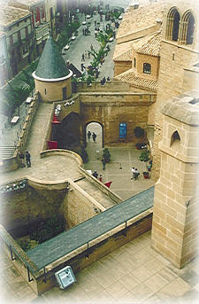
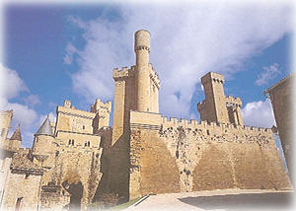
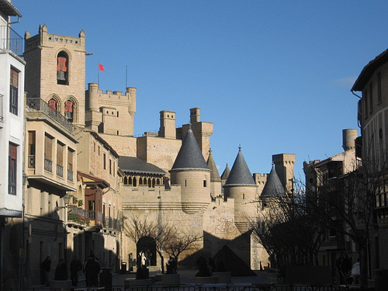 | 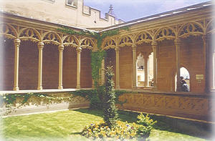
THE CHURCH OF SANTA MARÍA DE OLITE

The church of Santa María de Olite is one of the most important Gothic buildings in Navarre. Its artistic beauty is as interesting as its history. Lying adjacent to the old Royal Palace, the favourite residence of King Carlos III the Noble, it was used by Navarrese monarchs for great festivities and solemn ceremonies. Its elaborate façade, in which you can see the influence of the workshops of Nôtre Dame in Paris, will detain you and invite you to peruse the stories in the doorway. Inside, the single-nave church houses a Renaissance altarpiece presided over by a Gothic sculpture of the Virgin Mary and an image, also Gothic, of the Christ of the Good Death. The church of Santa María is the venue for the Navarre Organ Music Series which is held between May and November.
The church of Santa María stands in the medieval town of Olite, the main town in the municipality of the same name in the Central Zone of Navarre, and is a Gothic building whose construction lasted from the 12th century through to the beginning of the 14th.
The façade is one of the most significant collections of Gothic sculpture in Navarre. Despite the profusion of adornment, it retains great refinement and balance. You can appreciate the work of various master craftsmen and the influence of Parisian workshops. Elsewhere in Navarre, the churches of the Holy Sepulchre of Estella and San Saturnino in Artajona feature similar models.
Under a huge rosette, the main doorway is made up of eight archivolts which display exuberant plant motifs. Amongst the mass of leaves you can make out two figures praying under pelmets; this is possibly Juana I of Navarre and her husband, the King of France, “Philip the Handsome”, who reigned in Navarre during the period in which the front was built.
In the tympanum you can see a smiling Virgin Mary, seated with the Child, and various scenes from the life of Jesus: the Annunciation, the Birth of Christ, the Massacre of the Innocents, the Flight to Egypt, the Presentation in the Temple and the Baptism of Christ. In the lintel you will be entertained by a piece in which reality and symbolism become confused: a man perched up on a holm oak shares the scene with a hybrid creature playing the bagpipes and a grotesque quadruped, amongst other characters. The wealth of iconography continues on both sides of the door, where you can find reliefs of the lives of the apostles framed by a series of arches.
Going into the church, which has just one nave, you will discover another of the buildings great treasures: a magnificent high altarpiece in Renaissance style, presided over by a lovely Gothic carving of the Virgin and Child dating from the 14th century, in the Navarrese style with a French influence.
In the church, the Christ of the Good Death is worshipped, a Gothic work from the 14th century, seemingly from the now-disappeared church of San Lázaro. The town professes great devotion for this crucifix of such great dramatic quality, and the patron saint festivities are held in its honour.
The church of Santa María de Olite is also one of the venues for the Navarre Organ Music Series, which is organised by the Government of Navarre and takes place between May and November.
After visiting the church, the Royal Palace of Olite awaits you, one of the most important Gothic castles in Europe, as well as the winding streets of the town which reveal all the splendour of its medieval past.
